You are invited to participate in a research study being conducted by (insert TMA name) in partnership with the North Jersey Transportation Planning Authority (NJTPA) to evaluate the effectiveness of the Street Smart NJ pedestrian safety education campaign program. In the following pre-campaign survey, the team seeks information about your knowledge, behaviors, and attitudes toward this campaign. You will be asked to complete a post-campaign survey in a few weeks. These surveys are very similar but it is very important to complete both surveys.

This survey should take you approximately 5 to 10 minutes to complete. Your participation in the survey is completely voluntary, and there are no risks to participation. You may skip any questions you are not comfortable answering. If at any time you wish to stop participating, you are free to do so with no penalty to you. This research is confidential. Confidential means that the research records will include some information about you, such as your job title. However, the (insert TMA name) team is the only parties that will be allowed to see the full set of data, except as may be required by law. If a report of this study is published, or the results are presented at a professional conference, only group results will be stated. All study data will be kept for three years post study.

If you have any questions at any time about the research or the procedures described above, or if you need assistance in completing the survey, you may contact the (insert contact name or ogranization with email address).
Please print a copy of this consent form for your records. If you are 18 years of age or older, understand the statements above, and will consent to participate in the study, click on the "I Agree" button to begin the survey. If not, please click on the “I Do Not Agree” button which you will exit this pro
The North Jersey Transportation Planning Authority (NJTPA) is working to improve pedestrian safety in New Jersey. Your answers to this survey will help make this effort a success. All responses will remain STRICTLY CONFIDENTIAL.

Screener________________________________________________________________

S1. Are you 18 years of age or older?
- Yes
- No

S2. Where do you live?
- Insert name of community where campaign is taking place
- Other: ______________ (name and zip code)

S3. Do you work, go to school, or regularly frequent (e.g., for shopping, social events, errands, or recreation) (insert name of community where campaign is taking place)?
- Yes
- No

Questions____________________________________________________________

1. At intersections with a traffic light and pedestrian signal, you should begin walking when the pedestrian signal shows: (select all that apply)
- A WALK sign or person walking
- A flashing hand or flashing DON’T WALK sign
- A countdown signal
- A fixed hand or fixed DON’T WALK sign

2. To the best of your knowledge, can you receive a ticket in New Jersey for…
- For crossing against the walk signal or when don’t walk is displayed Yes No
- Crossing the street in an unsafe manner outside of a crosswalk Yes No
- Using a hand-held cell phone while crossing the street Yes No
- Not stopping for pedestrians in a crosswalk Yes No
- Using a hand-held mobile device while driving Yes No
- Failing to stop for a person crossing when turning Yes No

3. In the last 30 days, have you read, seen or heard any messages addressing the following… (select all that apply)
- Speeding/aggressive driving
- Driving under the influence of alcohol
- Driving under the influence of a drug
- Drowsy driving
- Seat belt use
- Distracted driving
- Pedestrian safety
- Bicycle safety
- None of the “above”

4. Have you read, seen or heard any message or signage that mentions “Street Smart”?
- Yes
- No

5. In the last 30 days, have you read, seen or heard any messages similar to the following…

- 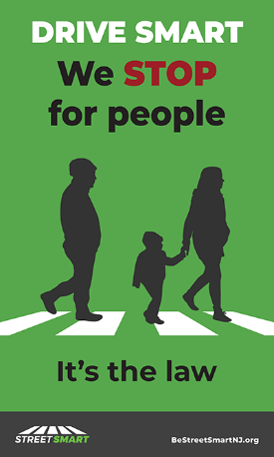
  - Yes
  - No

- 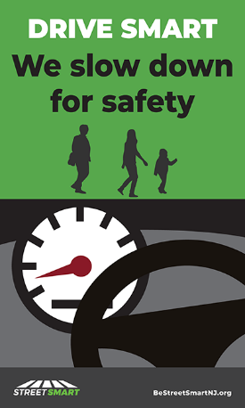
  - Yes
  - No

- 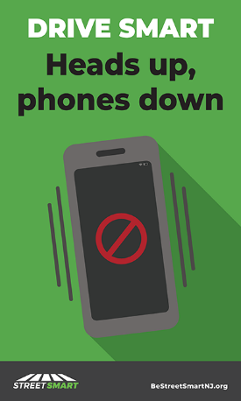
  - Yes
  - No

- 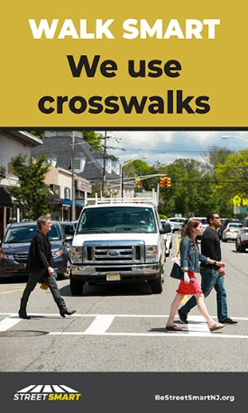
  - Yes
  - No

- 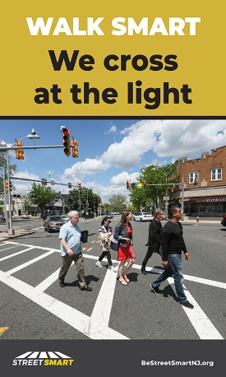
  - Yes
  - No

- 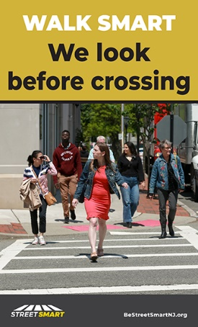
  - Yes
  - No

6. If you saw or heard any of the message in question 5, where did you see or hear them? (select all that apply)
- Radio
- Streaming radio
- Television
- News
- On posters or signs you have seen while driving
- On posters or signs you have seen while walking
- On posters or signs at transit stations and on or in buses
- On table tent cards
- Safety tip cards or fact sheets distributed by your places of employment or schools
- Safety tip cards or fact sheets distributed by law enforcement officers, family, friends, community organizations, volunteers on the street or businesses
- Social media sites (e.g., Facebook, Twitter, and Instagram)
- Internet advertising
- Other (Please specify: ________)

7. In the past month, have you seen or received information about pedestrian safety from any of the following sources (check all that apply)
- Emails from your employer or school
- Emails from friends, family, community organizations or businesses
- Newsletters distributed by your employer or school
- Newsletters distributed by community organizations or places of worship
- Local newspapers
- Social media sites
- Other (Please specify: ________)

8. Have you recently read, seen or heard about the following police efforts to enforce pedestrian safety laws? (Check all that apply)
- Police issuing tickets or warnings for people who crossed the street in an unsafe manner
- Police issuing tickets or warnings to drivers for “Not stopping for pedestrians in crosswalks”
- Other (Please specify ___)
- Never

9. What mode(s) of transportation do you use on a weekly basis? (check all that apply)
- Bicycle
- Bus
- Car
- Commuter boat, ferry
- Commuter rail
- Motorcycle or Moped
- Personal Transportation Device (Mobility Scooter, Skateboard, Rollerblades, etc.)
- Subway
- Walk
- Other (Please specify: _________)

Demographics__________________________________________________________

For classification purposes, please tell us a few things about yourself. Your responses will be kept strictly confidential and this information will not be connected to you personally.

D1. What is your gender?
- Male
- Female
- Rather not say
- Other

D2. What is your age?
- 18-24
- 25-34
- 35-44
- 45-54
- 55-64
- 65-74
- 75 years and over
- Rather not say

D3. What is your race? (check all that apply)
- White
- Black or African American
- Asian
- American Indian
- Alaska Native
- Native Hawaiian
- Other Pacific Islander
- Other, (Please specify_______)
- Rather not say

D4. What is your ethnicity?
a) Hispanic or Latino
b) Not Hispanic or Latino
c) Rather not say

D5. Do you speak any languages besides English at home?
- No
- Yes
→ If Yes-> (Please specify_______)

D6. What is the highest level of education you have completed?
- Less than a high school diploma/equivalent
- Some high school or high school graduate
- Some college
- Associates’ degree
- Bachelor’s degree
- Advanced degree

D7. Are you enrolled in any type of education institution like university, college, community college or technical training program?
a) Yes, full time
b) Yes, part time
c) No

For a chance to win $100 gift cards enter your contact information. All information is kept strictly confidential and will not be shared with any third parties. Only winners are contacted. If you do not wish to enter the contest, do not enter any information below. When you are finished, please click on the "Submit" button below to submit your responses.
- Name
- Email
- Phone
- Address

We thank you for your time spent taking this survey. Your response has been recorded.

Survey is completed____________________________________________________

